# Gravity Modelling–Testing Hypotheses Using Gravity Data

# How is the high topography of the Himalaya and Tibetan Plateau supported at depth?

The aim of this practical is to use a forward modelling approach (using the semi-infinite slab approximation) to assist in the interpretation of the gravity anomalies observed along three transects (lines 1, 2 and 3) for the Himalaya-Tibetan Plateau region (see maps below).

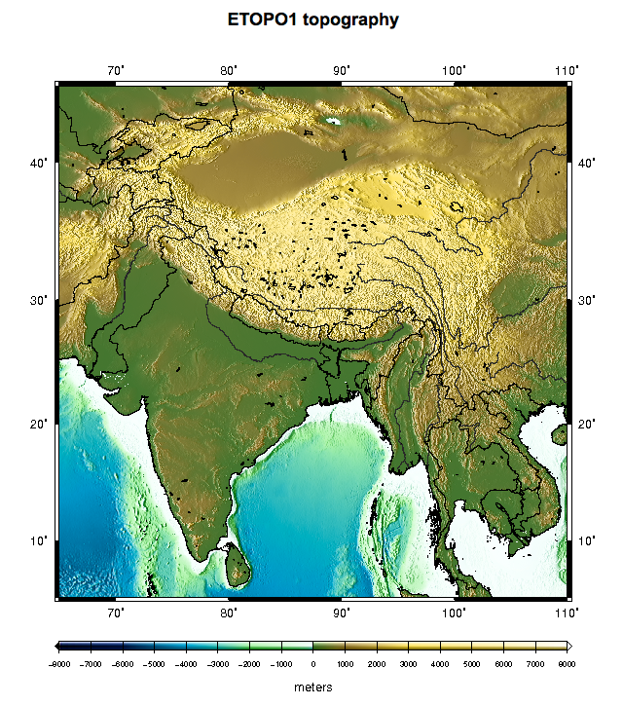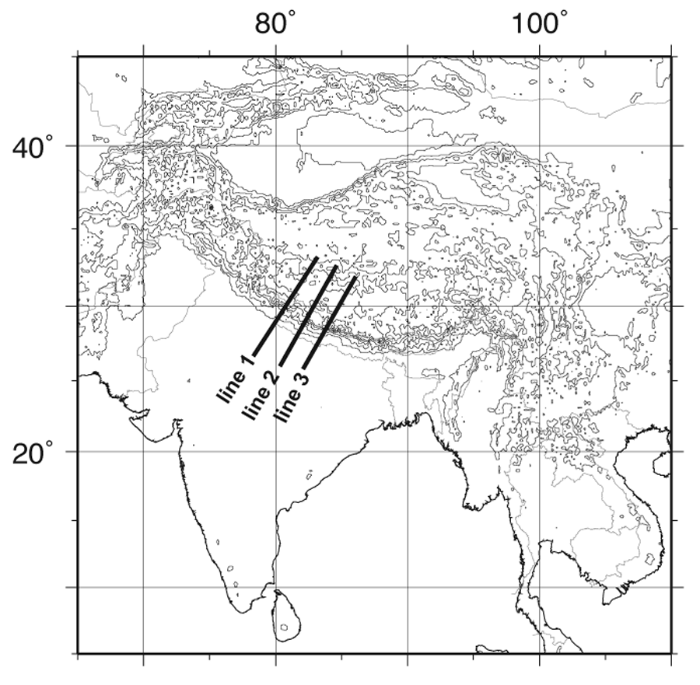

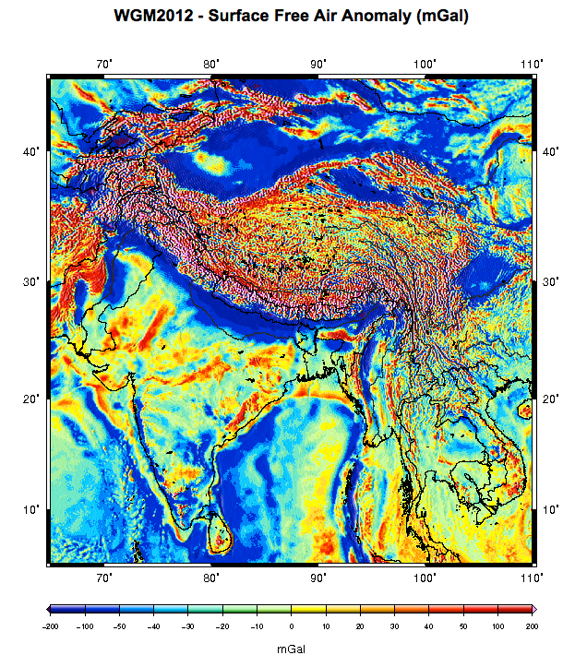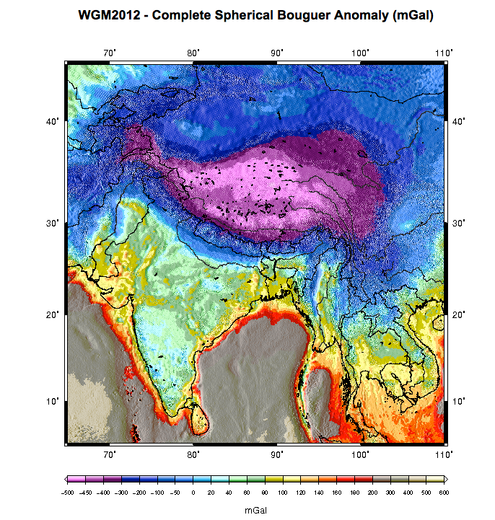

**Task 1.**

Down load the observed gravity data for the three transects (lines 1, 2 and 3) from the Moodle site. These are provided in two formats; simple ascii text files (one file per line) and also as an Excel file (one file, each line on a separate workbook page). Use either format, whichever suits. These data were extracted from the WGM2012 data set which is the first release of a high resolution grids and maps of the Earth's gravity anomalies (Bouguer, isostatic and surface free-air), computed at global scale in spherical geometry. See the BGI website for further details; <http://bgi.omp.obs-mip.fr/data-products/Grids-and-models/wgm2012>

Process the raw gravity data for each line (using the 1967 Standard Gravity Formula) and calculate the Free Air and Bouguer anomalies for each line.

Inspect the gravity anomaly profiles for each line by plotting graphs of the anomaly values and topography (scale topography as required) on the y-axis versus centre distance on the x-axis. Compare the shape and magnitude of the anomalies with respect to the topography (i.e. elevation) for each transect. Compare the observed anomalies to those analysed in the previous lab session for a mountain in Airy isostatic equilibrium.

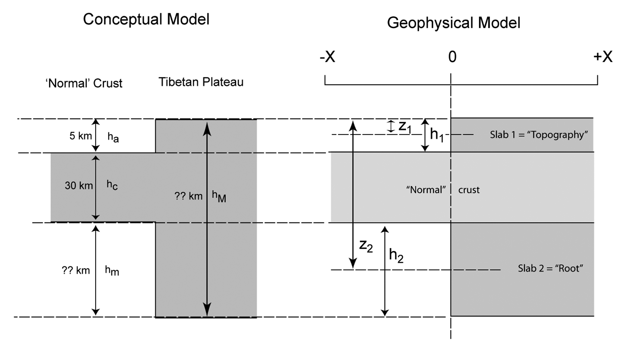**Task 2.**

Use an Airy isostatic model and a simplified crustal structure such as illustrated in the sketch above to calculate the thickness of the crustal root (hm) and the total crustal thickness (hM ) under the Tibetan Plateau assuming the surface topography is completely supported by the crustal root, i.e. it is in Airy isostatic equilibrium (c = 2.67, m =3.1, a = 0 all in g.cm-3).

**Task 3.**

For each of the lines 1, 2 and 3 implement an appropriate forward model using Excel and the **semi-infinite slab approximation** (see pages 250, 257 and 258, Chapter 8, Lillie) to model the Free Air gravity anomaly and the Bouguer gravity anomaly along each transect.

Ensure that you calculate the **Root Mean Square Deviation (RMSD)**, i.e. the average misfit between your model predictions and the observations, for each model and compare this with the mean standard deviation on the observations for the transect.

Also, make sure you plot a set of suitable graphs to illustrate the observed anomaly data, topography and your model results for each transect/line, ensuring that a plot of the residuals is also included to aid the evaluation and assessment of the model.

Given that our model design is very simple, you may also want to investigate whether an “average model”, i.e. a model that attempts to fit the mean of the observations calculated across all three lines. That is calculate the mean Free Air anomaly and the mean Bouguer anomaly (based on the three transect values available) and fit a simple model to these mean values.

**Task 4.**

• Read the papers discussing the gravity and structure of the Himalaya-Tibetan Plateau listed on Moodle (Braitenberg et al. 2000; Cattin et al. 2001, and Lyon-Caen and Molnar, 1985).

• Compile all the outputs from the tasks 1 to 3 (include a simple sketch for your model design (from Task 1), and you must show your workings for the calculation of *hm* and *hM* in Task 1) into a brief report (not more than 1500 words).

• Discuss how your model performed and how it enabled (or otherwise) the interpretation of the observed gravity data, and the implications of your model and the observed gravity data for the state of isostatic equilibrium of the Tibetan Plateau.

• Explicitly discuss, and quantify using the appropriate statistics, how well your model fitted the observed data and whether, and to what extent, a model of local (Airy type) versus regional (flexural) isostasy is applicable to explaining how the topography of this mountain chain is supported. Comment/discuss your results/conclusions in light of those reported/discussed in the literature.

**You must submit this report for assessment by the appropriate deadline (see Moodle site for this year’s deadline).**